**Insight 1:** <https://drive.google.com/file/d/13ah6kMu9aPzdJo7aGdBVurhppKsaVRH5/view?usp=sharing>

The first thing we did is make a map showing which states lean in which direction based on how many presidents and vice presidents or elected from those States. The map is white in places where there were no presidents or vice presidents born from, blue in places where there were more Democrats who were born there, red in areas that had more Republicans, and purple in areas that elected an equal number of Democrats and Republicans. There were other colors like yellow and orange for if there was an equal amount of people who were not Republican or Democrat elected as either Republicans or democrats, black if there was ever an equal amount of any which there wasn't, and green if there were more people who were other that were elected than either democrat or republican, my code also included cyan but that was just to make sure I didn't do anything wrong and thankfully there was no cyan anywhere on the map. (You also might want to look at the actual file that the code was submitted on because it has a better picture than the one it downloaded, for example on the picture you have without that you can't see that Delaware is actually green)

**Insight 2:**

This box plot shows the political parties of people who were elected and what year they were born, it shows that over time as people are born more and more with me hate end more towards being democratic. (The picture it downloaded is horrendously squished, so I would just advise running the actual code to be able to see it)

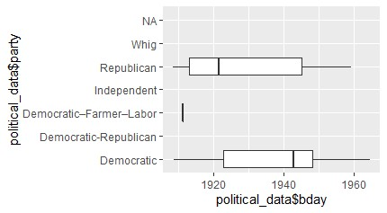

**Insight 3:**

*Professions of Vice Presidents: Professions of Presidents:*

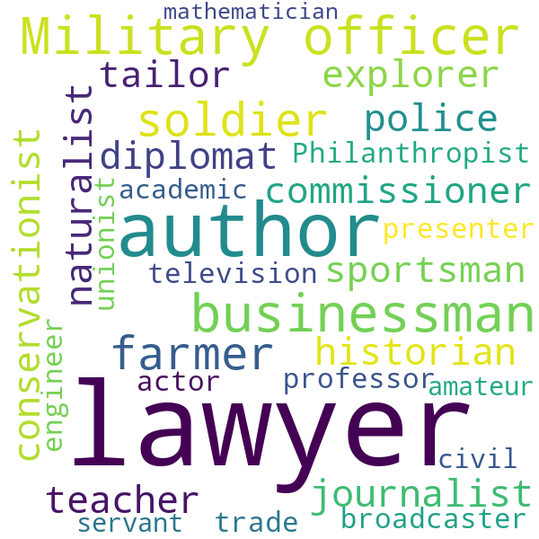

The five most common professions for American vice presidents (excluding the unknowns) were “lawyer,” “author,” “environmentalist,” “businessman,” and “journalist.” The five most common professions of American presidents were '”lawyer,” “author,” “businessman,” “Military officer,” and “soldier.”

**Insight 4**: 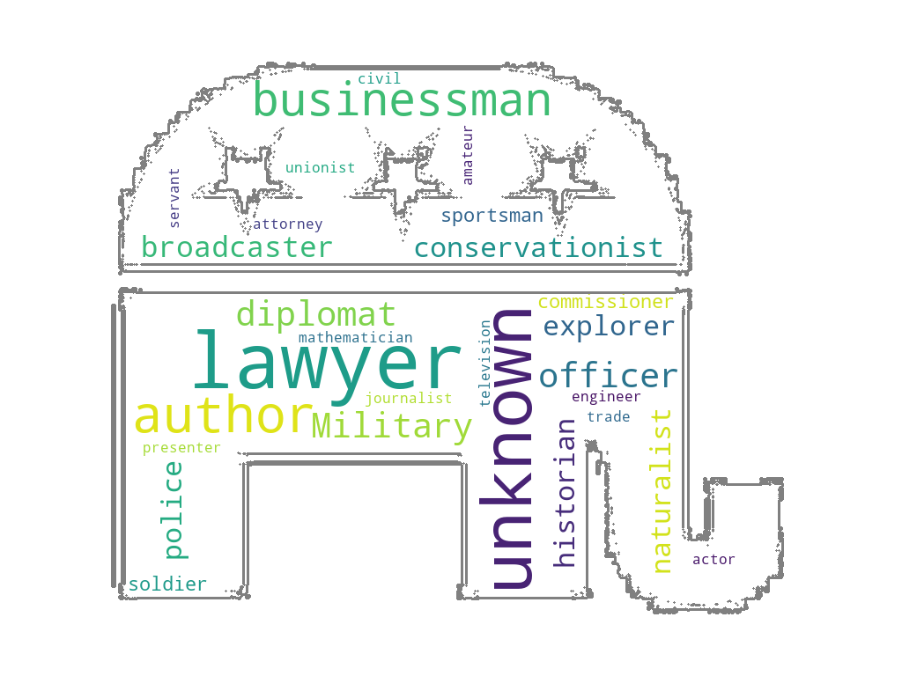

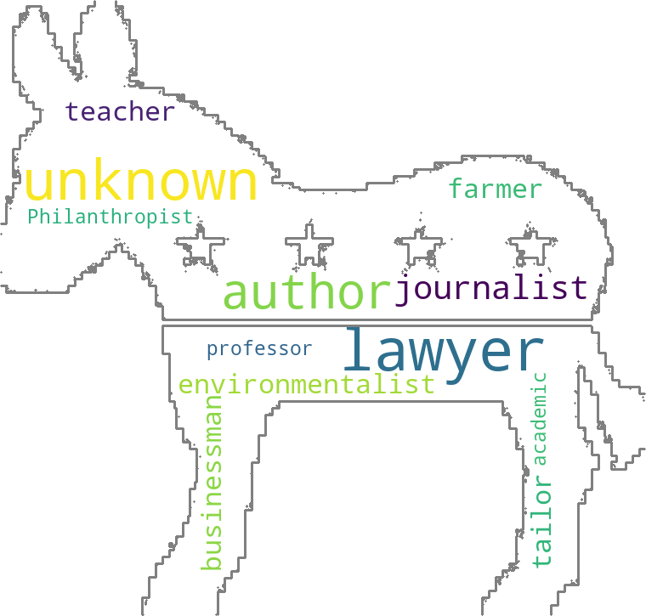

The top 5 most common occupations for politicians from the Republican party are “lawyer,” “author,” “businessman,” “diplomat,” and “military officer.” The top 5 most common occupations for politicians from the Democratic party are “lawyer,” “author,” “journalist,” “teacher,” and “farmer.” The word clouds above visualize the professions, in order of abundance, from the Republican and Democratic party.

**Insight 5:**

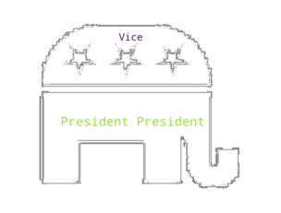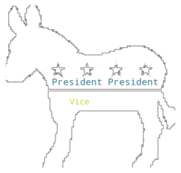

Most politicians from the republican party were presidents and most politicians from the democratic party were also presidents.